**Outcome :**

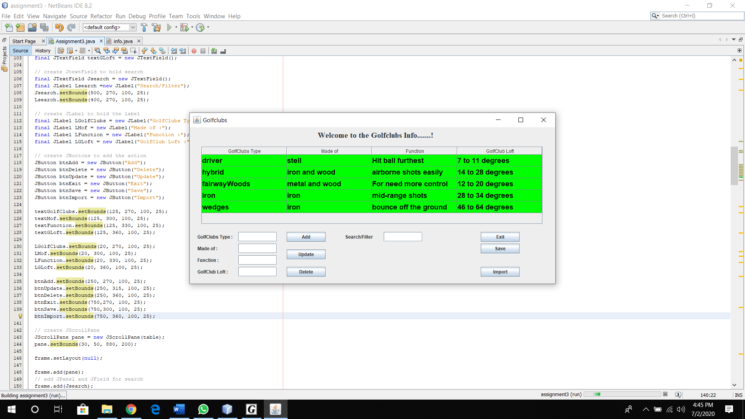

**Add info :**

Step 1 : Insert the information you want.

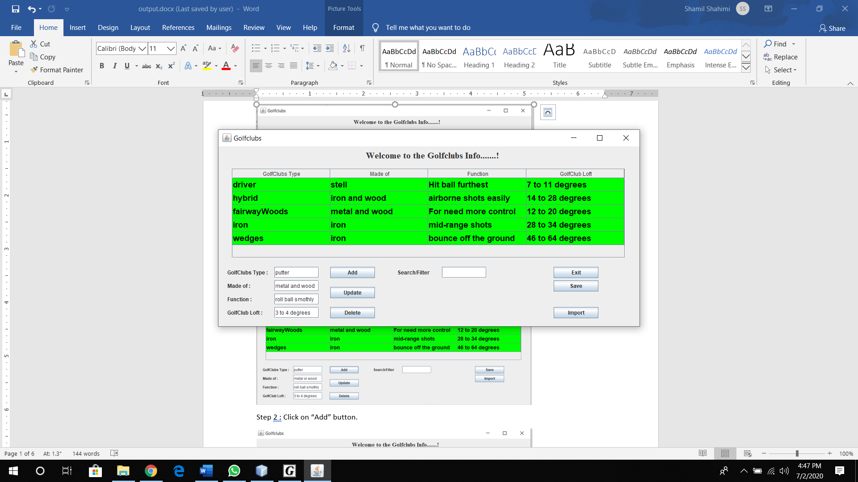

Step 2 : Click on “Add” button.

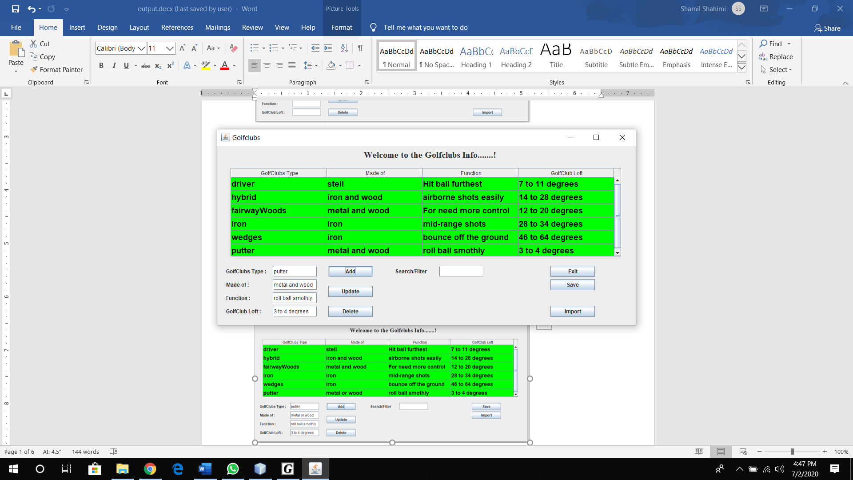

Update information :

Step 1 : Click on which bar you want to edit.

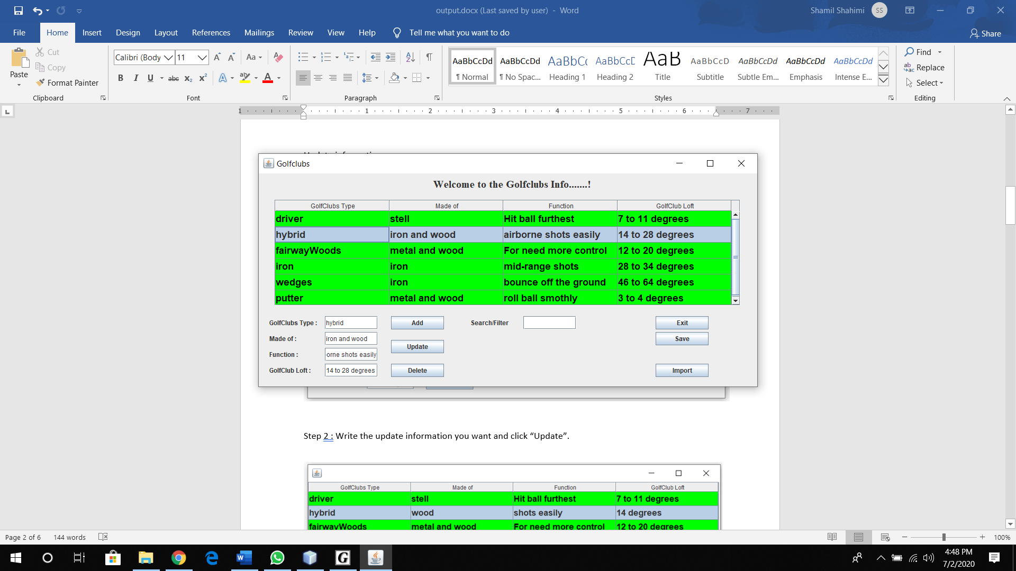

Step 2 : Write the update information you want and click “Update”.

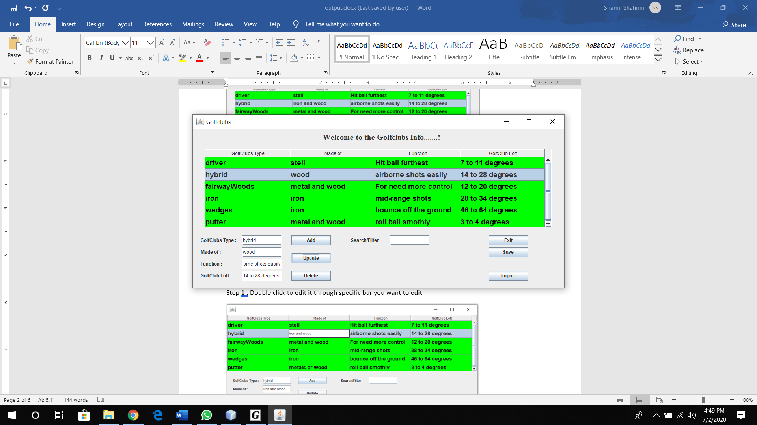

**Delete information :**

Step 1 : Click on any information you want to delete.

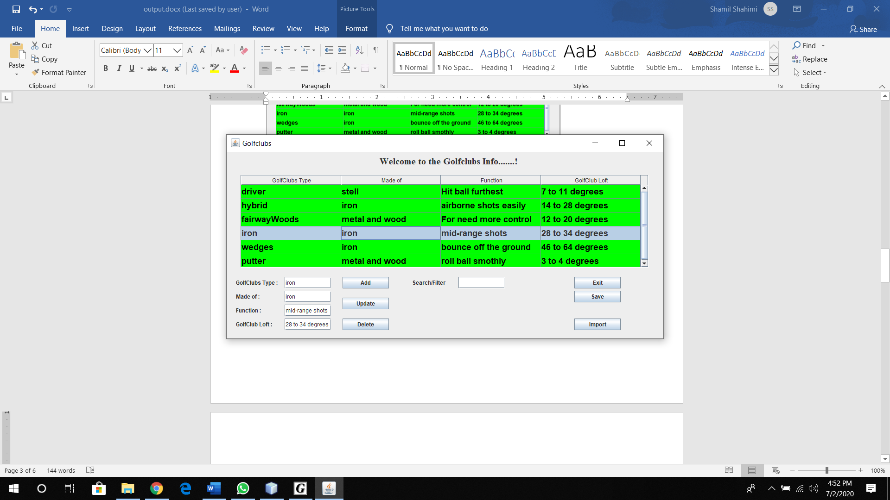

Step 2 : Click on “Delete” button.

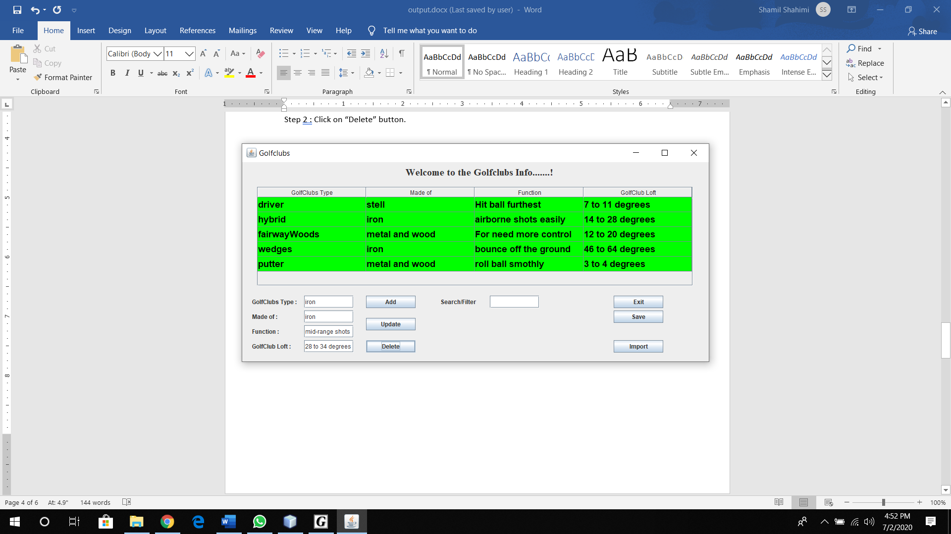

**Search :**

Step 1 : Click on the search/filter text bar.

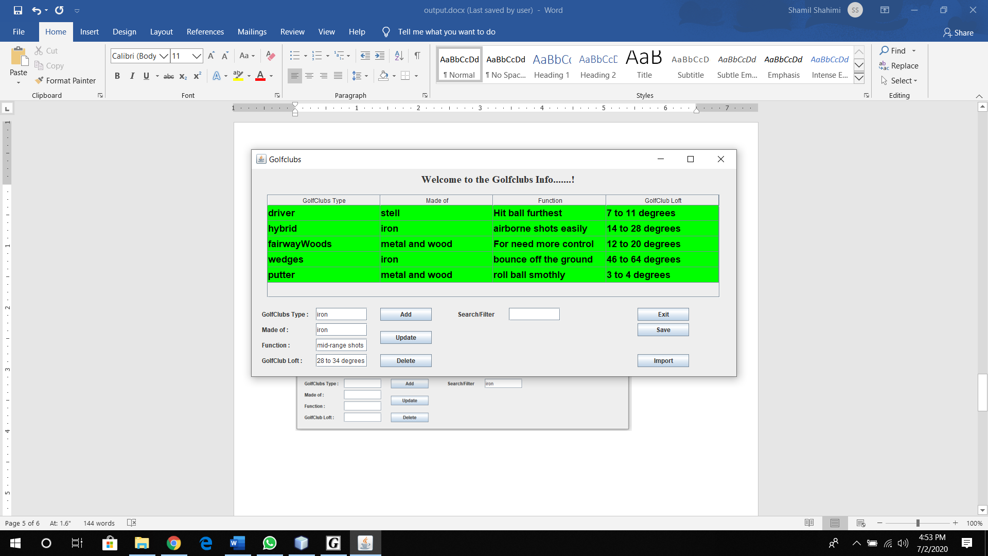

Step 2 : Write any information you want to search for.

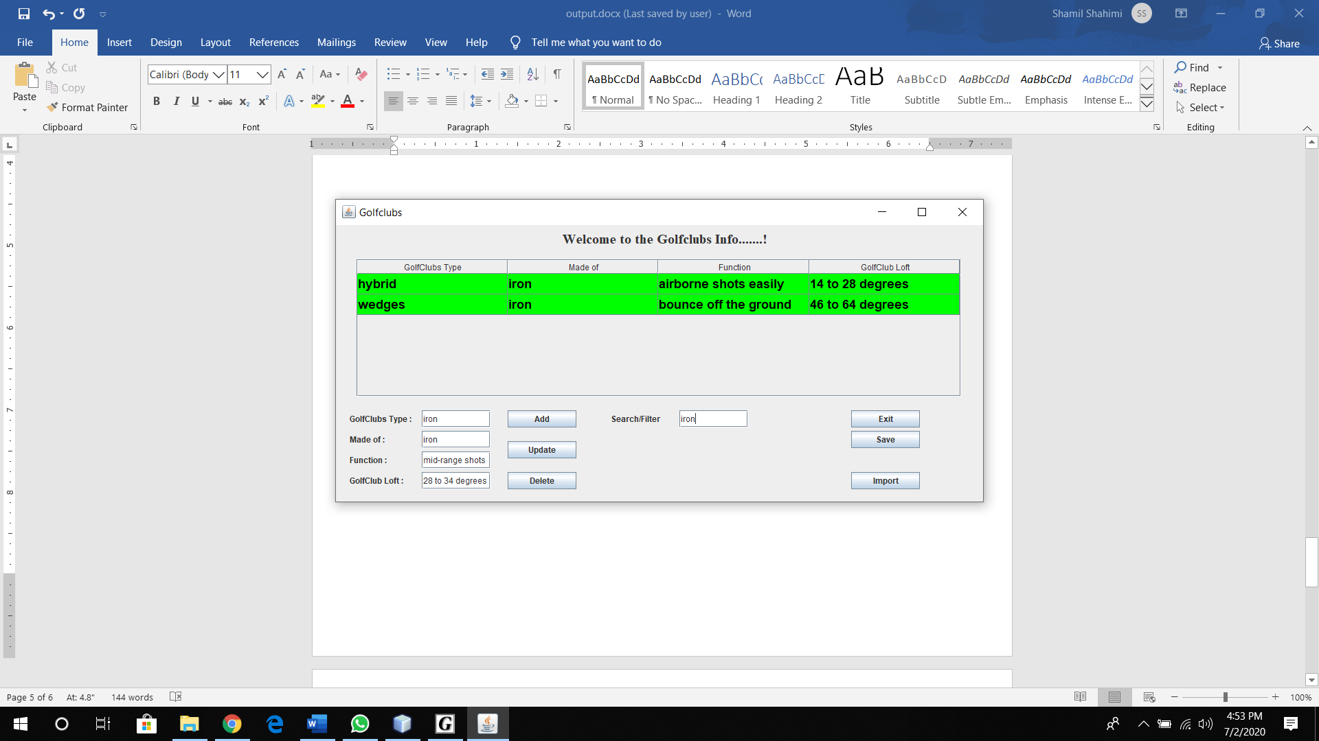

**Save :**

Step 1 : Click on the “ Save ” button and your data will be save .

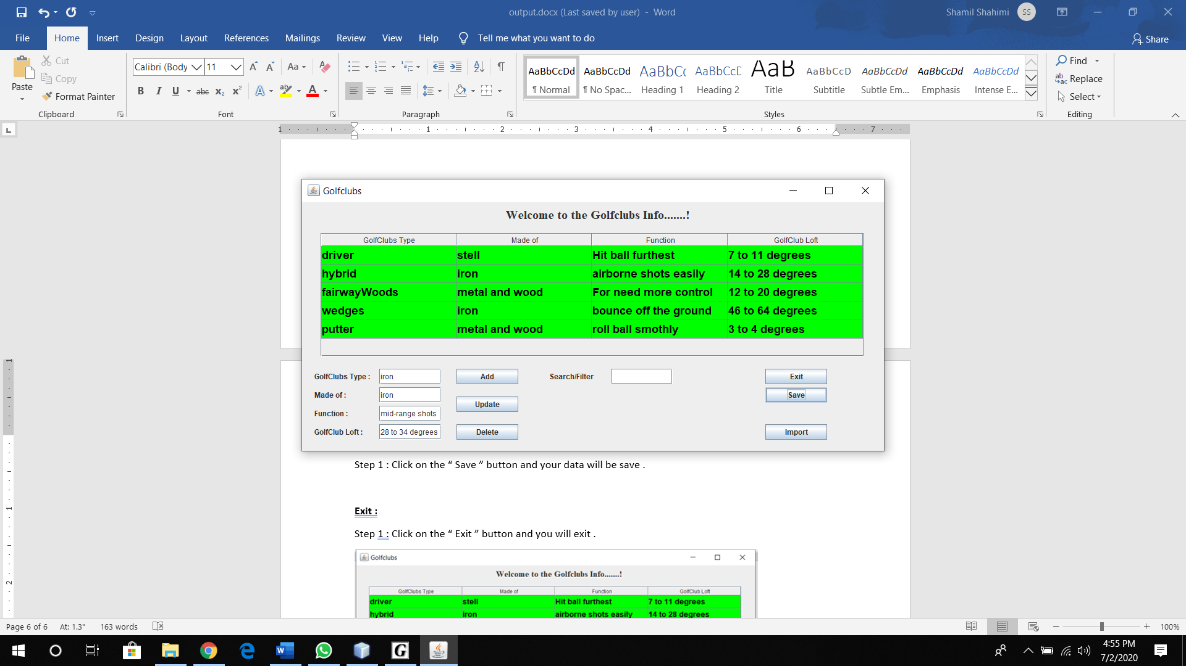

**Import previous saved data :**

Step 1 : Click on the “ Import ” button and your previous data will appear.

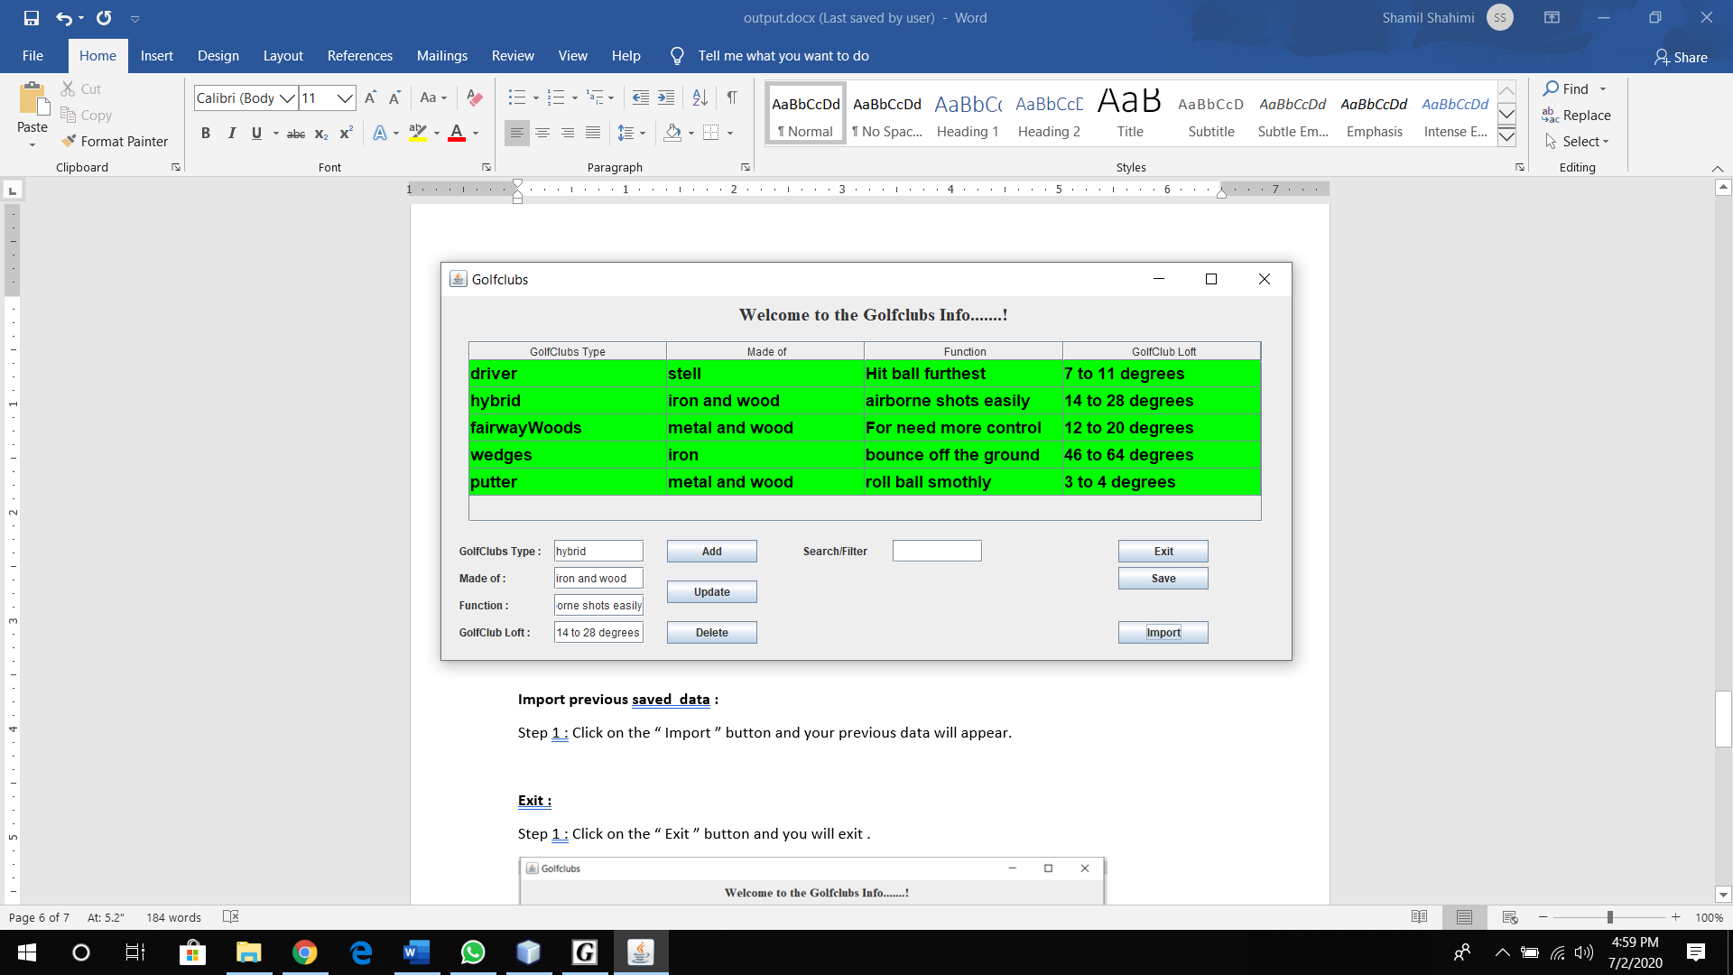

**Exit :**

Step 1 : Click on the “ Exit ” button and you will exit .

